***FITTON & VAUGHTER***

***Allies & Aviators***

**The story of a brief friendship in WWII**

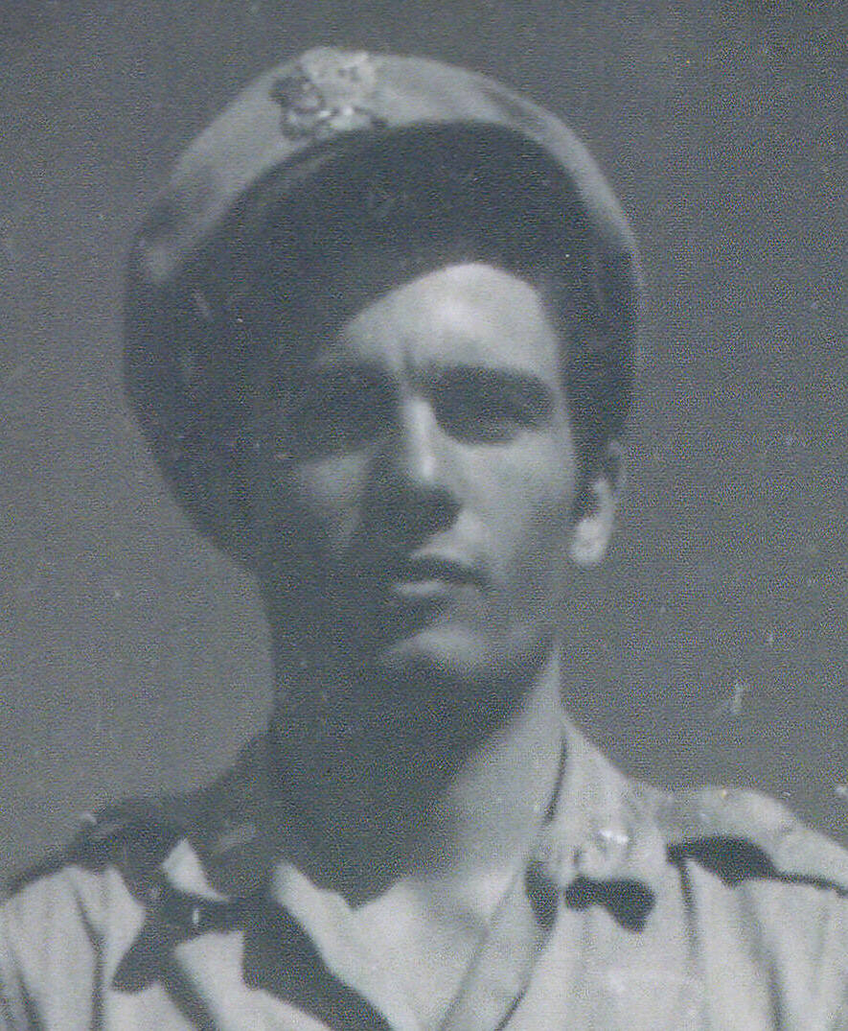

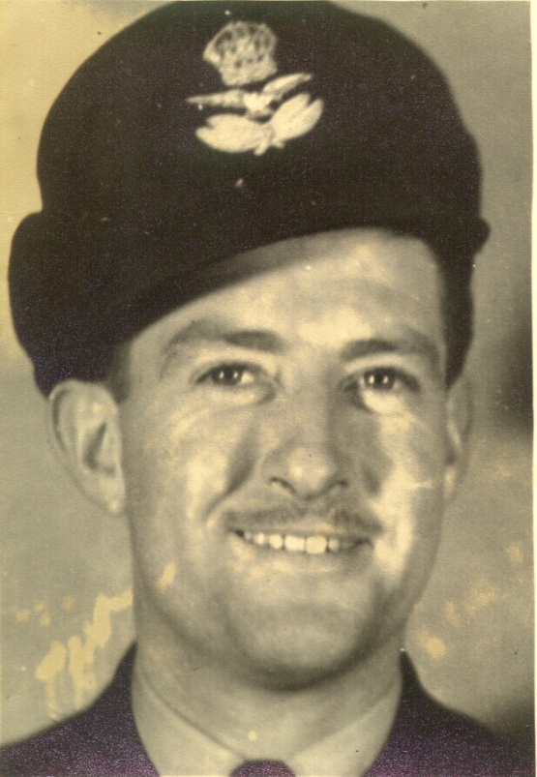

**Keith A. FITTON** **David C. VAUGHTER**

Born 1916 – NSW, Australia Born 1921 – New Mexico, USA

***Flight Lieutenant RAAF (KIA)*** ***Captain USAAF (Ret.)***

This document has been assembled by Diane Fitton using information from various sources, including the following:

*Keith Anthony Fitton*

*Beaufighters in the Pacific (N.M. Parnell)*

*Australia in the War of 1939-1945 (George Odgers)*

*31 Squadron Narrative*

*Ian Wickens, Ian Cobb (son of Allan Cobb) and Fred Anderson*

*OZATWAR Website and Peter Dunn*

© Diane Fitton - 2012

**The Search for Lt Vaughter**

Late in 2011, Keith & Diane Fitton began looking into the flying history and service record of Keith’s father, Keith Alexander Fitton. On the last page of his Log Book, Keith Jnr noticed a flight conducted in a C-47, registered VH-CFL, with a ‘Lt Vaughter’. Keith Jnr thought that this had to be a US Air Force Pilot and wondered why he was flying an Australian registered aircraft on a wartime mission in north western Australia. Then, in the book *Beaufighters in the Pacific*[1], Keith Jnr read a passage which mentioned *“a distinguished Yank Pilot, formerly on Moresby Bully Beef transports”*. This had to be our ‘Lt Vaughter’ and so a search began.

‘Vaughter’ was an unusual name but the quest turned out to be anything but simple. There were many Vaughters in various records (*Social Security, Military Enlistment Papers, Obituaries, etc*) but without a given name the search was almost impossible. One *Lt James Victor Vaughter* looked promising but he had flown only in Europe and was a POW at the time of this flight.

On 23rd February 2012, after months of searching and many dead ends, an Internet listing was found for VH-CFL. This showed that the aircraft had arrived at Amberley on 11th November 1943 for use by the 5th Air Force; and that it was operated by 21st Troop Carrier Squadron. A search for that Squadron turned up the OZATWAR website. In order to narrow down the search on this comprehensive website, an email was sent to the originator, Peter Dunn, giving him the information on Lt Vaughter and asking which squadrons would have been known as ‘Bully Beef transports’. Peter replied within the week, forwarding an email that he had received from a David Vaughter in December 2009! Peter had contacted David to obtain information on the crash of a C-47 at Cooktown on 11th June 1944.

Was this our Lt Vaughter? Should we send an email? What about privacy – what if we brought back bad memories? With about one second’s thought, an email was sent to David asking if he was the pilot of VH-CFL on the *Potshot*-Kalgoorlie flight in March 1944.

The very next day a reply was received and David was indeed the ‘distinguished Yank’ **and** the person named in Keith Snr’s Log Book. David remembered the flight and especially remembered flying in a Beaufighter with Keith Snr – information not included in the initial email! What a thrill!

There followed many communications and an exchange of photographs which all helped to fill a gap in the family history and to paint pictures of these two warriors.

This contact was of significance for Keith Jnr because his father was killed fifteen days after that flight from Coomalie. On 28th March, Keith Snr flew No. 2 in a flight of six Beaufighters which carried out a raid on Roti Island, Timor. It was his first sortie into enemy territory and he was piloting the aircraft he had collected from Kalgoorlie. Whilst making a second strafing run on a prahu which was beached at the head of Pepela Bay, Keith hit the mast of the lugger and crashed inverted. Crews in the formation considered that Fitton, and his Navigator Raymond Foyle, had no possible chance of survival.

For twenty months the family held out hope for Keith’s survival despite receiving several communications stating that he had almost certainly been killed in the crash. In November 1945 a RAAF Search Party recovered the remains of Fitton and Foyle from Pepela Bay where they had been buried by a young English-speaking Christian Rotinese native, Andreas Toelle. It was at this time that Keith Jnr was told his father would not be coming home.

**31 Squadron & the March 1944 emergency**

Keith Snr had arrived at Coomalie Creek in the Northern Territory on 28th February and on 9th March normal operations were interrupted by the arrival of several Japanese aircraft carriers at Singapore.

The whole of 31 Squadron (124 personnel) moved to *Potshot* in nine Dakotas and fourteen Beaufighters. *(Fourteen Beaufighters against a Japanese fleet – what were they thinking?)*

Fred Anderson, Navigator for J.A.P. (Pat) Boyd, kept a diary and noted that some of the Squadron flew to Exmouth Gulf *(Potshot)* on 10th March.

David Vaughter, in VH-CFL, with Keith Fitton and other Beaufighter crews on board, flew to *Potshot* on Sunday 12th March. David remembers the flight well due partly to the bad weather at the time. Their alternate airport at Onslow was under eighteen inches of water and that left *Potshot* as the only airport within fuel range. David remarked *“we were just lucky to be able to find the phone/power lines between the station and Potshot”*. They encountered typhoon winds of 65mph *(57kts)* with gusts to 90mph *(78kts)* on landing.

The Australian Group Captain in charge of the operation told David that they were in **urgent** need of replacement aircraft which were sitting at Kalgoorlie. He asked David if he would take crews down to collect them. David asked why they didn’t take one of the five other C47s that were sitting at *Potshot* and the boss told him that he had asked and none of them wanted to go. The boss thought that, seeing as how David had just flown through the typhoon, he might be willing to take off into it again and fly to Kalgoorlie.

The Beaufighter crews were asked if they would go with Vaughter and they replied that they would ride anywhere with him. The aircraft was supplied with enough fuel to get to Geraldton where the crews spent the remainder of the night. The next day, Monday 13th, the journey to Kalgoorlie was completed.

There were four Beaufighters awaiting collection: A19-169, A19-177, A19-181 and A19-182. Keith did a test flight on A19-181 on 13th with three crew and the following day this aircraft was flown to *Potshot* via Meekatharra by Pat Boyd & Fred Anderson.

On Wednesday 15th, Keith carried out a 40 hourly Test on A19-169 with Lt Vaughter listed as crew. David vividly remembers this flight as it was his first in a combat aircraft. He said that Keith let him handle the controls while they flew alongside the big water supply pipe for Kalgoorlie and Boulder; a double treat for David.

On Thursday 16th, Allan Cobb and Syd Green, carried out a flight test on A19-177. *(These two gents were close friends of Keith Snr and were greatly affected by his loss)*

On Saturday 18th, two Beaufighters flew from Kalgoorlie to Geraldton where they overnighted before completing the trip to *Potshot* on the following day. Keith & Flt/Sgt Warner flew A19-182 and Allan Cobb & Syd Green flew A19-177. Keith, in a letter home, wrote that both he and Allan Cobb were happy with “*their very own, personal Beaufighter*”, the latest type, which was their’s to look after and do with what they liked. Keith had planned to get his own coat-of-arms painted on the nose as soon as possible.

On 23rd March all squadron personnel and aircraft left *Potshot* to return to Coomalie. Boyd & Anderson flew via Wyndham and arrived Coomalie at 8.30pm. Keith’s Log Book shows that he and Warner flew to Port Hedland where they overnighted, arriving at Coomalie the next day. Ian Wickens also overnighted at Port Hedland, he didn’t know why. Cobb & Green overnighted at Broome.

**History of the emergency**

(Extracted from *Australia in the War of 1939-1945, Series Three – AIR, Vol. II Air War Against Japan 1943-1945*. By George Odgers. Pp 136-138)

On Saturday, 4th March 1944, Australia’s Prime Minister Curtin cabled Churchill for an opinion on Japanese naval moves and the possibility of incursions into the Indian Ocean. The British assessment was reassuring.

However, on 7th March a US submarine which was north of Lombok Strait made radar contact with two heavy vessels. It was known that two battleships with escorting destroyers had left Singapore on 4th sailing in the direction of Surabaya. Thinking that Fremantle might be the objective, the following actions were taken.

All local defences were manned. Five submarines in Fremantle were ordered to form a patrol to seaward and all necessary steps were taken to clear the harbour by Thursday afternoon.

General Headquarters took immediate steps to send air reinforcements to the west coast, as follows:-

No. 380 Bombardment Group was to return from New Guinea to base at Fenton in NT

No. 43 Sqdn (*Catalinas*) was to move to Darwin

Nos 452 & 457 Sqdns (*Spitfires*) were sent to Perth as fighter defence squadrons

No. 18 Sqdn (Dutch - *Mitchells*) was sent to *Potshot*

No. 31 Sqdn (*Beaufighters*) was sent to *Potshot*

No. 84 Sqdn (*Kittyhawks*) was to move from Horn Island to Strauss to take the place of the Spitfires in defence of the NW Area

No. 120 Squadron (Dutch - *Kittyhawks*) would reposition from Canberra to *Potshot*

Each squadron was to move in two parts, the first part to consist of the aircraft with their crews and the second of maintenance men and equipment sufficient for fourteen days.

News of the emergency in WA leaked out to the public and rumours spread of a coming Japanese invasion or air raid. No. 1 Fighter Wing squadron commanders were told that a “*Japanese naval task force was loose in the Indian Ocean headed in the general direction of the Perth area*”.

By Friday, 10th March, the men of squadrons 18, 31, 120 (Canberra, ACT) and 84 (Horn Island, Qld) were imbued with a sense of urgency and worked feverishly all night. By dawn next day the aircraft were ready to go. Squadrons 457 and 452 took off at 8.00am and 8.30am for Derby. Due to bad weather some pilots landed at Wyndham. Twenty-four machines of 84 Squadron had to turn back and one disappeared into the sea. The coastal bases through which the squadrons were being sent did not have sufficient men or adequate refuelling equipment for the sudden demands and this imposed long delays.

Also on 10th March, the weather at *Potshot* was the worst possible. Severe cyclonic storms struck the area and converted the airfield into a swamp. The camp was flooded out and stores and equipment, which were dispersed in depressions, were covered with four feet of water. Aircraft wheels sank in the muddy ground.

The Dutch pilots of 120 Squadron flew their Kittyhawks across the Nullarbor Plain through Ceduna, Forrest and Kalgoorlie. At Kalgoorlie, Dakota and Kittyhawk aircraft were landing every ten minutes. *(Note: Fitton, Vaughter and 31 Squadron personnel arrived Monday 13th)*

By 12th March 452 & 457 Spitfire Squadrons were at Guildford ready to meet enemy raiders in the air. Together with No. 85 Squadron Boomerangs, they assumed the defence of the Perth-Fremantle area. No. 25 Squadron, flying Vengeances, was to make dive-bombing attacks if the enemy force came within 200 miles of the coast.

The whole emergency operation turned out to be abortive. The Japanese had no plan to attack in Western Australia or elsewhere in the Indian Ocean at that time.

**31 Squadron Images**

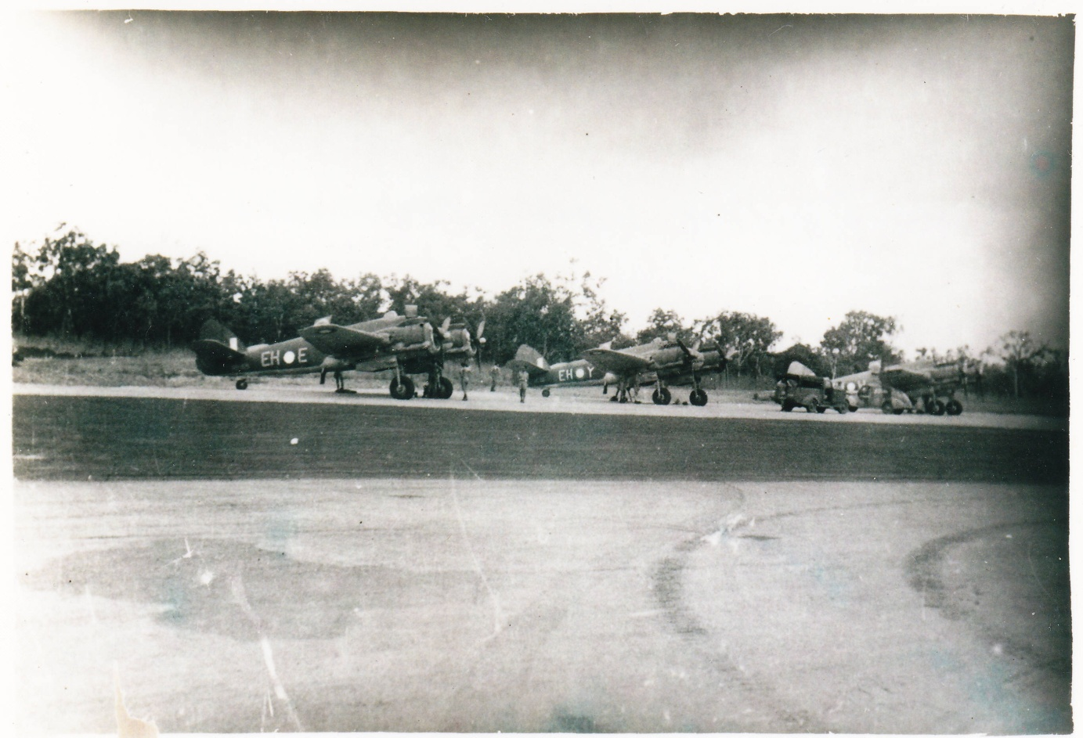

**Beaufighters on Coomalie strip February 1944**

(*image received from Ian Wickens March 1989*)

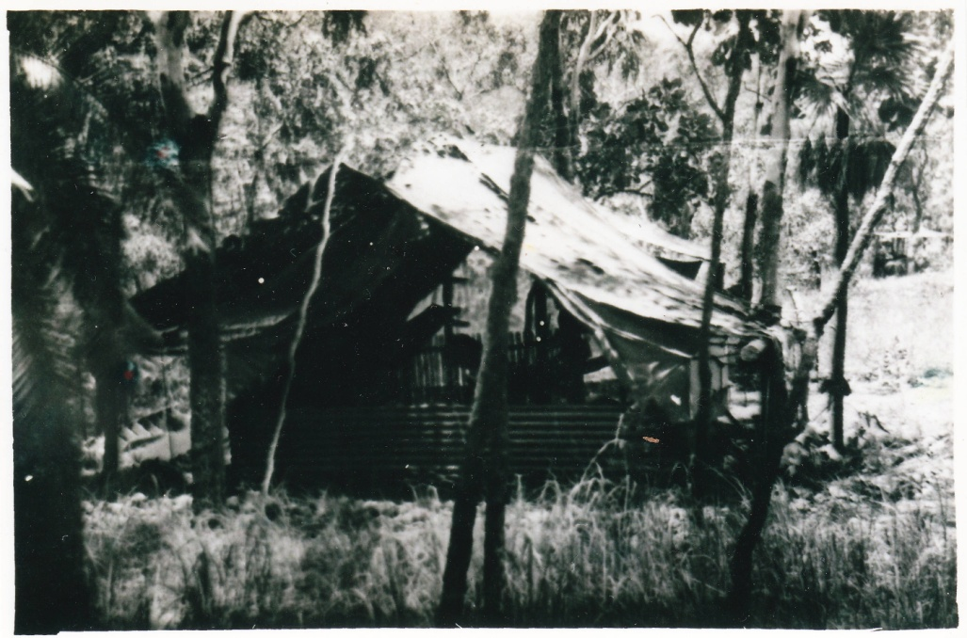

**Camp site Coomalie February 1944**

(*image received from Ian Wickens March 1989*)

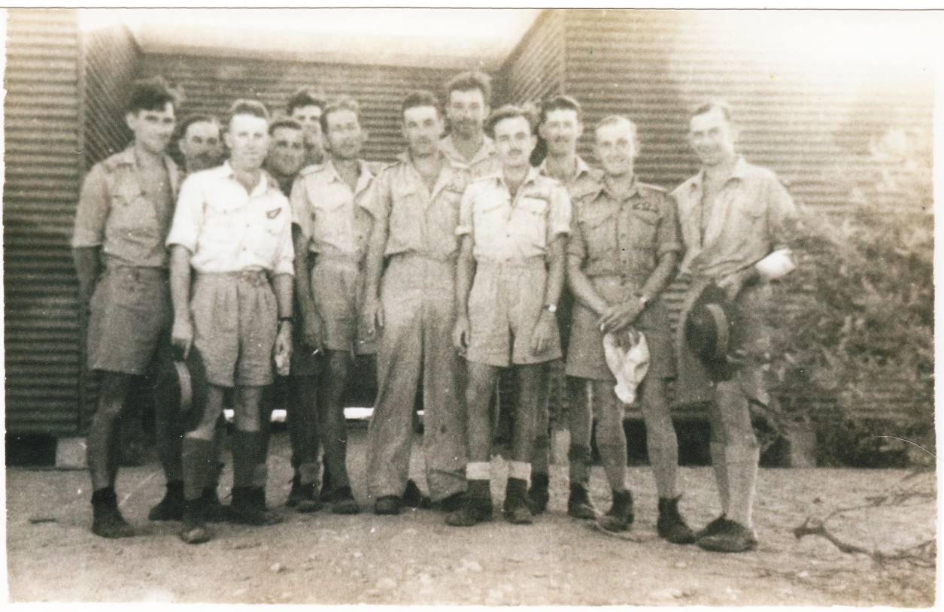

**Some 31 Squadron aircrew & officers at *Potshot*, Exmouth Gulf, W.A.**

**between 9th & 24th March 1944**

*(image* *received from Ian Wickens March 1989*)

Cleve Forrester (F/O), Ron Woods (Ops Officer), Syd Green (F/O), Len Mitchell (F/O),

Bob Miller (P/O), Wally McLean (P/O), John Garnham (F/O), Cyril Hansen (F/O),

Ian Wickens (F/O), Keith Fitton (Flt/Lt), Allan Cobb (F/O), Jim Moodie (Int. Officer)

In alphabetical order – Cobb, Fitton, Forrester, Garnham, Green, Hansen,

McLean, Miller, Mitchell, Moodie, Wickens, Woods)

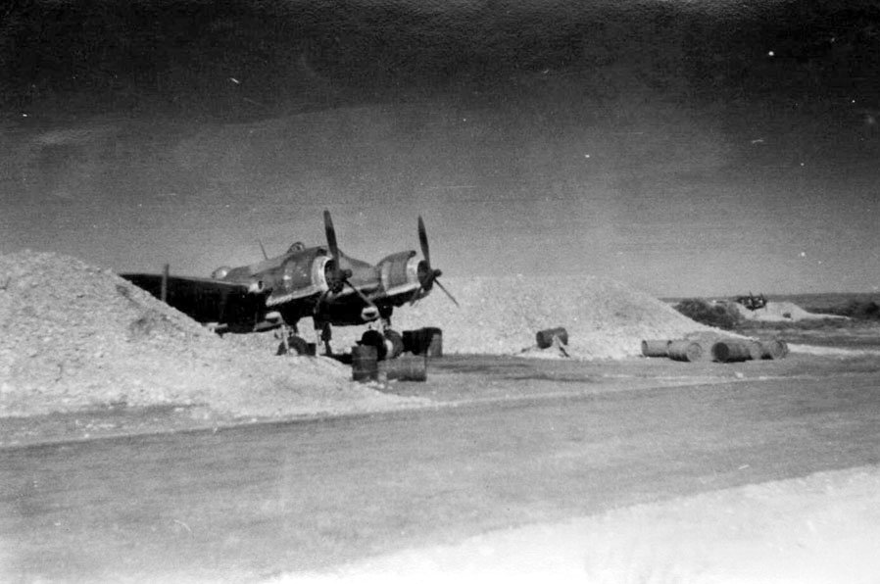

**Squadron Beaufighter at *Potshot* March 1944**

*(Photograph from AWM website)*

**Other Images**

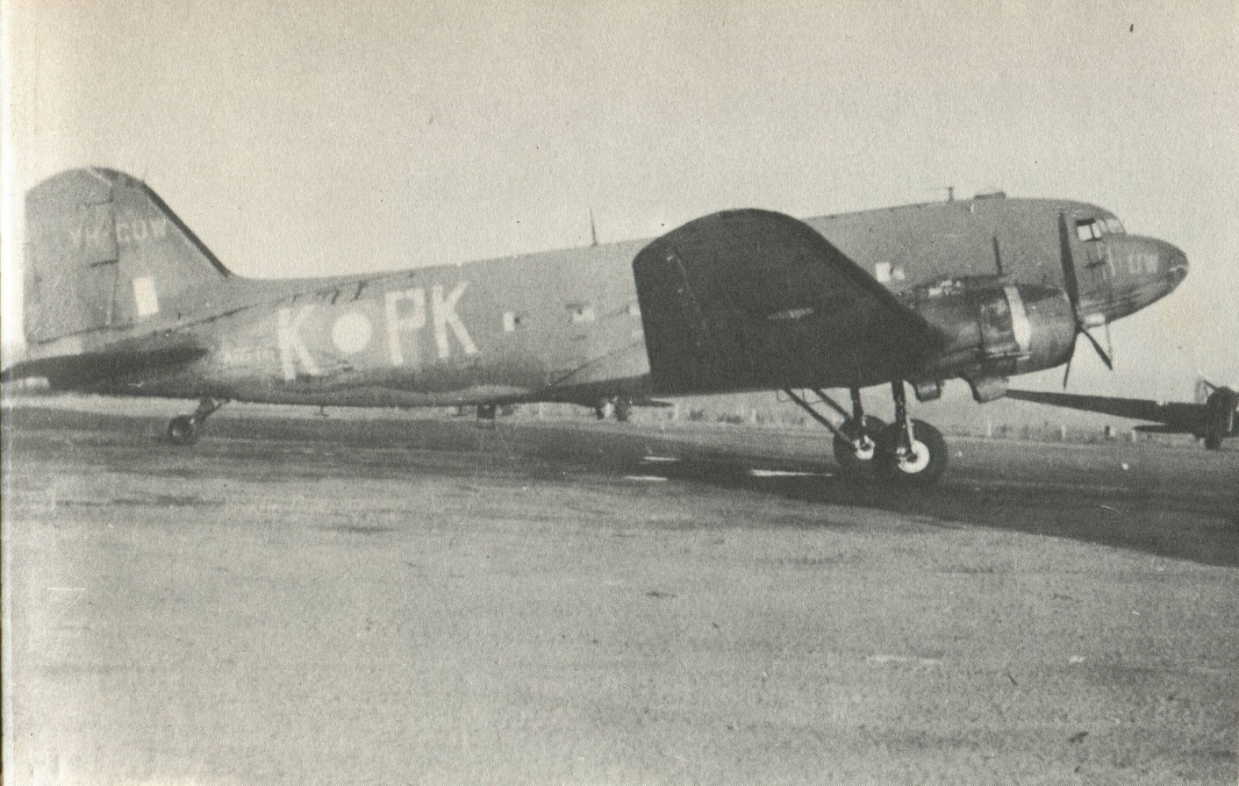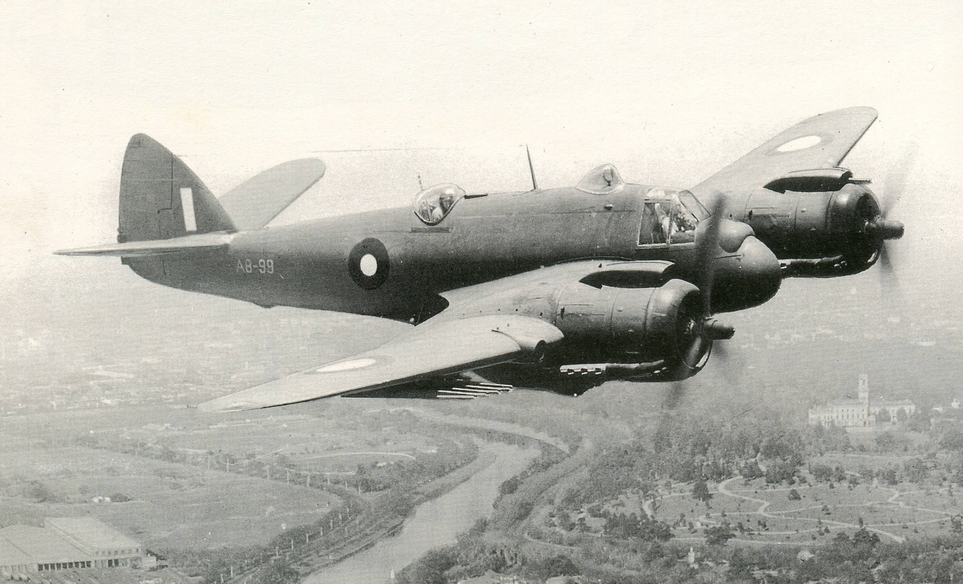An Australian-built Beaufighter XXI over Melbourne

*(*From the book *Beaufort, Beaufighter and Mosquito in Austalian Service* by Stewart Wilson*)*

A Douglas DC3 (*C-47*) used for supply dropping in the forward areas

*(*From the book *Aircraft of the RAAF 1921-71* by Pentland & Malone*)*

**Vaughter images**

*(Images & Articles received by mail from David Vaughter June 2012)*

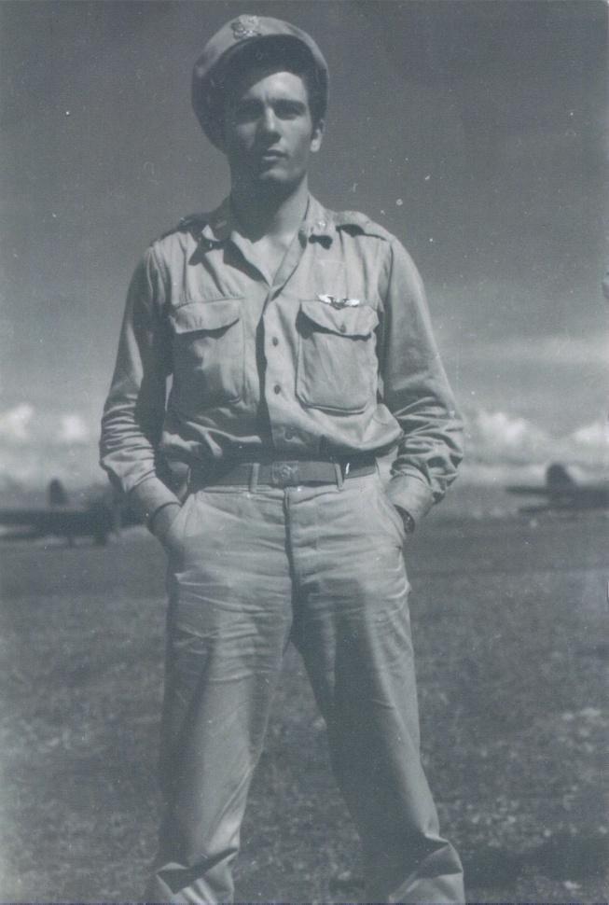

*(Written on the back)*

**Lieutenant David Vaughter**

Dobodora New Guinea

February 1944

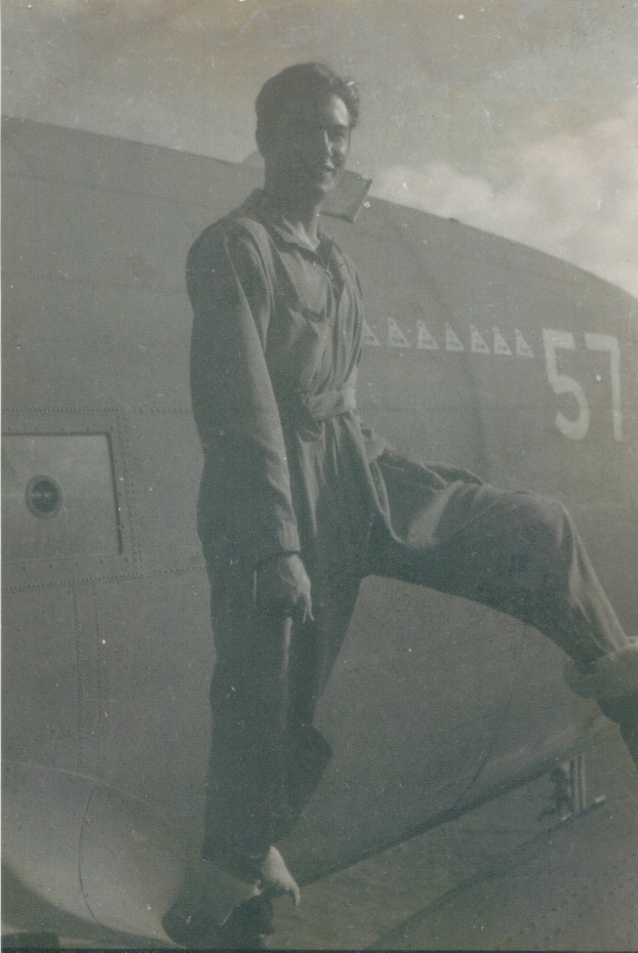

*(Written on the back)*

**Dave Vaughter**

in flight suit and Australian Flight Boots

on wing of C-47 #57 “Yard bird”

New Guinea - 1943

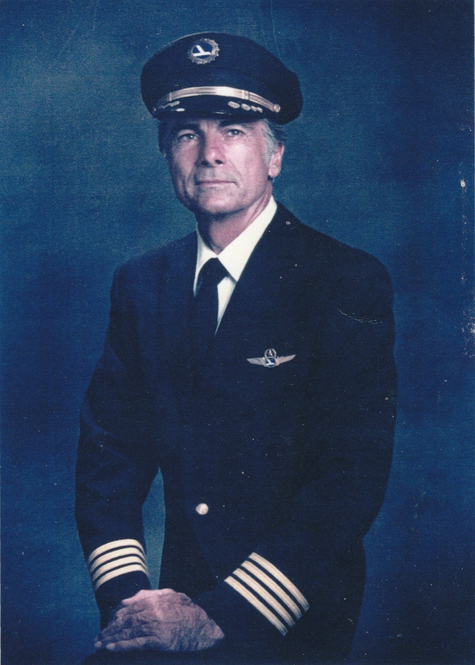

*(Written on the back)*

Eastern Airlines Captain

Retired Jan 1981

*Goggle Pix*

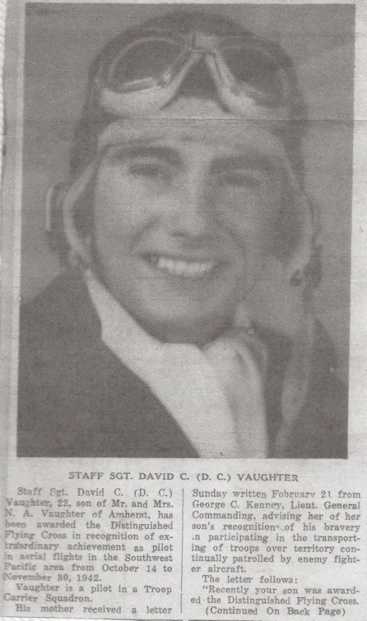

Staff Sgt. David C. (D.C.) Vaughter, 22, son of Mr & Mrs N. A. Vaughter of Amsherst, has been awarded the Distinguished Flying Cross in recognition of extraordinary achievement as pilot in aerial flights in the Southwest Pacific area from October 14 to November 30, 1942.

Vaughter is a pilot in a Troop Carrier Squadron.

His mother received a letter Sunday written February 21 from George C. Kenney, Lieut. General Commanding, advising her of her son’s recognition of his bravery in participating in the transporting of troops over territory continually patrolled by enemy fighter aircraft.

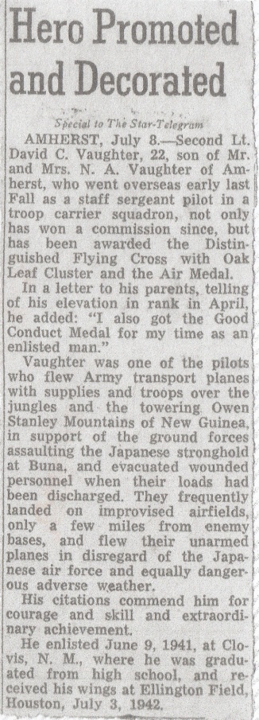

HERO PROMOTED and DECORATED

Special to the Star-Telegram

Amherst, July 8 – Second Lt. David C. Vaughter, 22, son of Mr & Mrs NA Vaughter of Amherst, who went overseas early last Fall as a staff sergeant pilot in a troop carrier squadron, not only has won a commission since, but has been awarded the Distinguished Flying Cross with Oak Leaf Cluster and the Air Medal.

In a letter to his parents, telling of his elevation in rank in April, he added: “I also got the Good Conduct Medal for my time as an enlisted man.”

Vaughter was one of the pilots who flew Army transport planes with supplies and troops over the jungles and the towering Owen Stanley Mountains of New Guinea in support of the ground forces assaulting the Japanese stronghold at Buna, and evacuated wounded personnel when their loads had been discharged. They frequently landed on improvised airfields only a few miles from enemy bases, and flew their unarmed planes in disregard of the Japanese air force and equally dangerous adverse weather.

His citations commend him for courage and skill and extraordinary achievement.

He enlisted June 9, 1941, at Clovis, N.M., where he was graduated from high school, and received his wings at Ellington Field, Houston, July 3, 1942.

*Newspaper article 1944*

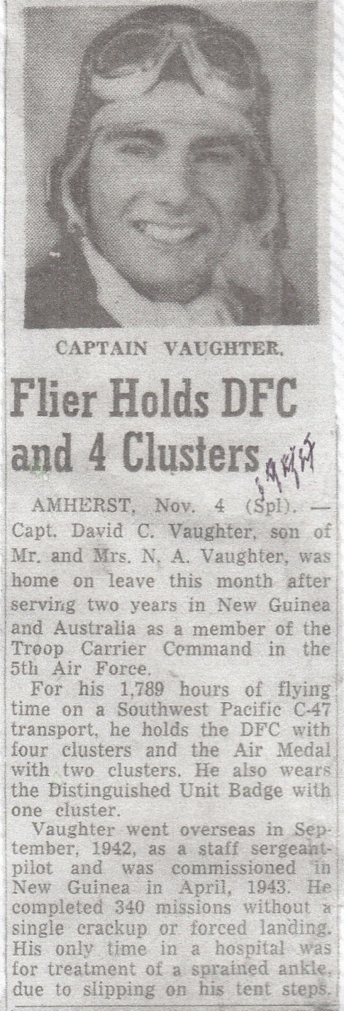

FLIER HOLDS DFC and 4 CLUSTERS

AMHERST, Nov. 4 (Spl). – Capt. David C. Vaughter, son of Mr & Mrs N.A. Vaughter, was home on leave this month after serving two years in New Guinea and Australia as a member of the Troop Carrier Command in the 5th Air Force.

For his 1789 hours of flying time on a Southwest Pacific C-47 transport, he holds the DFC with four clusters and the Air Medal with two clusters. He also wears the Distinguished Unit Badge with one cluster.

Vaughter went overseas in September 1942 as a staff sergeant pilot and was commissioned in New Guinea in April 1943. He completed 340 missions without a single crackup or forced landing. His only time in a hospital was for treatment of a sprained ankle due to slipping on his tent step.

***VH-CFL - Douglas C-47-DL - C/n 6071.***

|  |
| --- |
| **Construction completed at the Long Beach plant - November 30, 1942**  **Built as a Douglas C-47-DL**  **Delivered to the USAAF - December 1942**  **Allocated U.S. serial number 41-38676**  **Arrived Amberley for use by 5th Air Force - November 11, 1943**  **Operated by the 21st Troop Carrier Squadron using the radio callsign 'VHCFL'**  **Operated by the 6th Troop Carrier Squadron using the radio callsign 'VHCCY'**  **Aircraft was named 'Swamp Rat II'**  **Acquired by the Commonwealth of Australia / D.C.A. for use by airlines - July 10, 1944**  **Aircraft had flown only 1,980 hours 10 minutes**  **Entered onto the Australian Aircraft Register as VH-AEX - July 11, 1944**  **Registered to the Commonwealth of Australia**  **Leased to Guinea Airways Pty Ltd for use as a freighter - July 11, 1944**  **Converted to passenger configuration - November 17, 1944**  **Returned to Commonwealth of Australia - March 14, 1947**  **Registered to Australian National Airlines Commission for T.A.A. - March 28, 1947**  **Aircraft had now flown 8,125 hours 30 minutes**  **Aircraft was named 'Phillip'**  **Operated its first service with T.A.A. - March 28, 1947**  **Withdrawn from service and placed in storage at Melbourne - June 12, 1957**  **Had now flown 33,522 hours**  **Sold to Aero Equipment, Sydney - August 7, 1957**  **Sold to West African Airways Corporation - August 9, 1957**  **Cancelled from the Australian Aircraft Register - August 19, 1957**  **Registered VR-NCM - September 5, 1957**  **Aircraft was named 'Calabar'**  **Registered to W.A.A. (Nigeria) Ltd - October 1, 1958**  **Reregistered 5N-AAM in 1960**  **Transferred to Nigerian Air Force - becoming AAM - August 28, 1967**  **Withdrawn from use in 1972**  **Believed to have been broken-up at Lagos Airport, Nigeria - 1977 - 1978** |

|  |  |
| --- | --- |
| http://www.aussieairliners.org/dc-3/vh-aex/0250.567.jpg |  |
| **VH-AEX. Trans Australia Airlines - in the 'silver tail' livery at Melbourne's Essendon Airport, date unknown.** |  |

***Personnel:***

*Anderson, Fred (Frederick Bertram Anderson (Sgt, P/O) (32784)(14 Beaufighter Course)*

*Boyd, Pat – JAP Boyd, Flt Lt, Sqn Ldr (400691) (14 Beaufighter Course)*

*Cobb, Allan Herbert – Flt Lt. (423224) (14 Beaufighter Course)*

*Fitton, Keith Alexander – Flt Lt. (403730) (14 Beaufighter Course)*

*Green, Sydney Francis – Flt Lt. (412949) (14 Beaufighter Course)*

*Vaughter, David C. – Captain USAAF (Ret)*

*Warner, George Robert – W/O (418028)*

Cobb (Pilot) and Green (Navigator) placed *In Memoriam* notices for Keith in SMH 1946, 1947 & 1949. Fitton, Cobb & Green were on No. 14 Beaufighter Course. The three arrived at Coomalie 27 Feb 1944.

***Note****: on 20th June 1941 the United States Army Air Corps (USAAC) was retitled as the United States Army Air Forces (USAAF)*

Other manuscripts by Diane J. Fitton

Michael Alexander “Tui” Fitton – 0-18 years – This Is Your Life (© 1996)

Michael Alexander Fitton – 18-19 years – A Vintage Year (© 1997)

A Book of Verse (© 1997)

Dexter Group Newsletter (Dexter Doings) 10 issues Aug 2001-Oct 2003

Coral Sea Stories & Other Tales (© 2007)

History of the Dexter Group of North Coast NSW 1996-2008 (2 volumes - Compact & Compleat)

**INDEX**

A19-169, 5

A19-177, 5

A19-181, 5

A19-182, 5

Anderson, Fred, 4

Boyd, Pat, 4

Cobb & Green, 5

Cobb, Allan, 5, 29

Communiqués

Fitton-Vaughter 15/6/2012, 26

Fitton-Vaughter 18/5/2012, 24, 25

Fitton-Vaughter 23/5/2012, 25

Fitton-Vaughter 26/6/2012, 27

Fitton-Vaughter 29/2/2012, 21

Fitton-Vaughter 3/3/2012, 22

Fitton-Vaughter 30/5/2012, 26

Fitton-Vaughter 9/5/2012, 23

Vaughter-Dunn 1/12/2009, 21

Vaughter-Fitton 10/5/2012, 23

Vaughter-Fitton 17/6/2012, 27

Vaughter-Fitton 18/5/2012, 24

Vaughter-Fitton 2/3/2012, 21

Vaughter-Fitton 3/6/2012, 26

Vaughter-Fitton 30/5/2012, 25

Vaughter-Fitton 4/3/2012, 23

Coomalie Creek, 5

Curtin, Prime Minister, 5

Dunn, Peter, 3

Emergency, March 1944, 4

Foyle, Raymond, 4

Geraldton, 5

Green, Sydney, 5, 29

Japanese task force, 5

Kalgoorlie, 6

Onslow, 4

OZATWAR Website, 3

Port Hedland, 5

Potshot, 3, 4, 6

Reinforcements, Air, 6

Toelle, Andreas, 4

Vaughter – Note from friend, 18

Vaughter – Time-Life Article, 20

Vaughter – Time-Life Cover, 19

Vaughter Article 1942, 12

Vaughter Article 1944, 13

Vaughter Article 1964, 14

Vaughter Article 1967, 15, 16, 17

VH-CFL, 3

VH-CFL, History, 2, 28

Warner, R.G., 5

Wickens, Ian, 5

Wyndham, 5, 6

1. *Beaufighters in the Pacific,* by N.M. Parnell.Page 110:

   On 9th March there was some interruption to normal operations following the arrival of several Japanese aircraft carriers at Singapore. It was thought the Japanese intended attacking Western Australia. To be prepared, the whole squadron (124 personnel) moved to ‘Potshot’ in nine Dakotas and fourteen Beaufighters.

   *Notes by F.B. Anderson:-*

   *10 March - Flying at 8,000 feet over a dust storm, we arrived at Exmouth Gulf, a dusty, dry wilderness. They say it never rains.*

   *11 March - Rain and 40 mph wind. Demolished several tents, including ours. After drying out, spent hectic night in another tent, sleeping with blanket on galvanised iron.*

   *12 March - During a lull in the storm, four crews went to Geraldton and stayed overnight, causing consternation by our three days growth of beard and unwashed clothes.*

   *13 March - Flew in C-47 to Kalgoorlie – distinguished Yank pilot, formerly on Moresby ‘Bully Beef’ transports.*

   *14 March - Pat and I left KAL in Beau (A19-181) and arrived at Exmouth via Meekatharra.*

   *15 March - Standing by on strip. No-one knows what the score is. A Jap fleet is supposed to be approaching Perth.*

   *16 March - Spent a day on beach and fishing*

   *17 March - Tested kite. Swimming and fishing.*

   *18 March - Ate shark for tea after another day on beach.*

   *19 March - Saw films at US Navy base after a day on beach.*

   *20 March - No mail since leaving home. Swimming again.*

   *21 March - Another day at beach after a test flip and pictures at night.*

   *22 March - Five letters. Briefed for trip back tomorrow.*

   *23 March - Arrived at Coomalie 8.30pm via Wyndham, another dead town.*

   *The ‘emergency’ had subsided.*